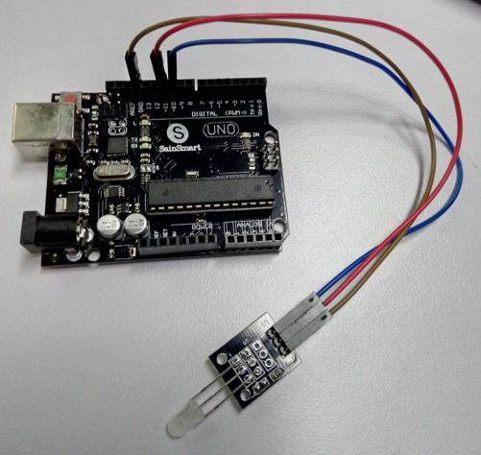

//Arduino test code:

int redpin = 11; // select the pin for the red LED

int yellowpin =10; // select the pin for the yellow LED

int val;

void setup() {

pinMode(redpin, OUTPUT);

pinMode(yellowpin, OUTPUT);

Serial.begin(9600);

}

void loop()

{

for(val=255; val>0; val--)

{

analogWrite(11, val);

analogWrite(10, 255-val);

delay(15);

}

for(val=0; val<255; val++)

{

analogWrite(11, val);

analogWrite(10, 255-val);

delay(15);

}

Serial.println(val, DEC);

}